April 26 – Bug Docu/Not working functionalities

Program Chair can’t Accept Dean’s Question
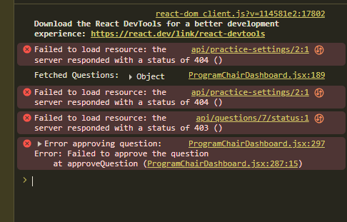

ERROR TEXT:
react-dom_client.js?v=114581e2:17802
Download the React DevTools for a better development experience: https://react.dev/link/react-devtools
❌ Failed to load resource: the server responded with a status of 404 () api/practice-settings/2:1

Fetched Questions: ▶ Object ProgramChairDashboard.jsx:189

❌ Failed to load resource: the server responded with a status of 404 () api/practice-settings/2:1

❌ Failed to load resource: the server responded with a status of 403 () api/questions/7/status:1

❌ Error approving question:
Error: Failed to approve the question
at approveQuestion (ProgramChairDashboard.jsx:297)
at approveQuestion (ProgramChairDashboard.jsx:287:15)
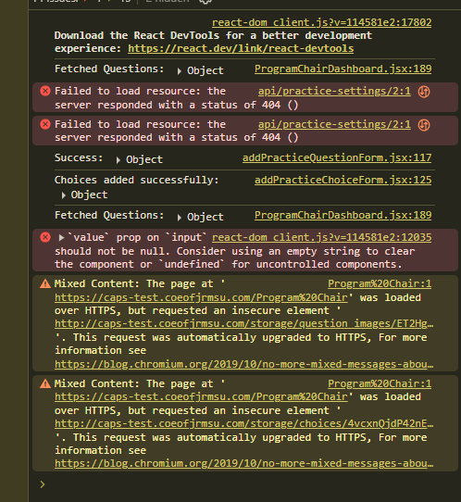
Image Can’t Be view in the Program Chair’s Board

ERROR TEXT:
react-dom_client.js?v=114581e2:17802 Download the React DevTools for a better development experience: https://react.dev/link/react-devtools
ProgramChairDashboard.jsx:189 Fetched Questions: Object
api/practice-settings/2:1

Failed to load resource: the server responded with a status of 404 ()Understand this error
api/practice-settings/2:1

Failed to load resource: the server responded with a status of 404 ()Understand this error
addPracticeQuestionForm.jsx:117 Success: Object
addPracticeChoiceForm.jsx:125 Choices added successfully: Object
ProgramChairDashboard.jsx:189 Fetched Questions: Object
react-dom_client.js?v=114581e2:12035 `value` prop on `input` should not be null. Consider using an empty string to clear the component or `undefined` for uncontrolled components.
validatePropertiesInDevelopment @ react-dom_client.js?v=114581e2:12035Understand this error
Program%20Chair:1 Mixed Content: The page at 'https://caps-test.coeofjrmsu.com/Program%20Chair' was loaded over HTTPS, but requested an insecure element 'http://caps-test.coeofjrmsu.com/storage/question_images/ET2HgbrKMGILPT1f7nqF8c1LPJBNNC2oALVyhFl6.jpg'. This request was automatically upgraded to HTTPS, For more information see https://blog.chromium.org/2019/10/no-more-mixed-messages-about-https.htmlUnderstand this warning
Program%20Chair:1 Mixed Content: The page at 'https://caps-test.coeofjrmsu.com/Program%20Chair' was loaded over HTTPS, but requested an insecure element 'http://caps-test.coeofjrmsu.com/storage/choices/4vcxnQjdP42nEEnyMZ8MHbPc7cKqvXZkJhd69OgS.jpg'. This request was automatically upgraded to HTTPS, For more information see https://blog.chromium.org/2019/10/no-more-mixed-messages-about-https.htmlUnderstand this warning

